1. Create a Java program to accept 10 numbers from user, store in an array. Find the

second largest and second smallest number from it. Use Scanner class to accept

input from user.

Solution :

import java.util.\*;

public class A1Q1{

public static void main(String arg[]){

int i,n=10;

int[] a = new int[n];

Scanner sn = new Scanner(System.in);

System.out.println("Enter the 10 numbers : ");

for(i=0;i<n;i++){

a[i]= sn.nextInt();

}

System.out.print("Elements are : ");

for(i=0;i<n;i++){

System.out.print(a[i]+" ");

}

System.out.println();

for(i=0;i<n;i++){

for(int j=i+1;j<n;j++){

if(a[i]>a[j]){

int temp = a[i];

a[i] = a[j];

a[j] = temp;

}

}

}

System.out.print("Sorted Elements are : ");

for(i=0;i<n;i++){

System.out.print(a[i]+" ");

}

System.out.println();

System.out.println("Second Largest No is :"+a[n-2]);

System.out.println("Second Smallest No is :"+a[1]);

}

}

Output :

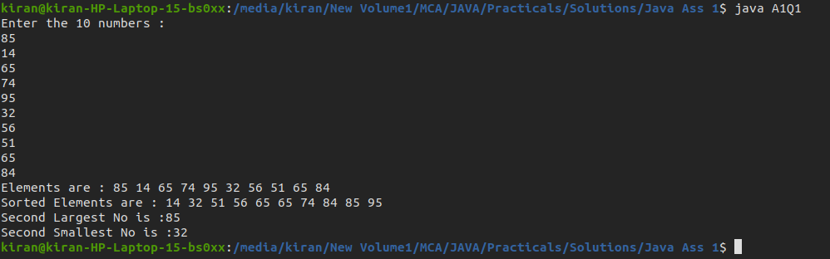

2. Create a Java program to accept number of strings from user and sort them in

alphabetical order. Use String class to store accepted string from user.

Solution :

import java.util.\*;

class A1Q2{

public static void main(String args[]){

String s[] = new String[100];

Scanner sn = new Scanner(System.in);

System.out.print("Enter the number to be accept the String :");

int n = sn.nextInt();

System.out.println("Enter the "+n+" Strings :");

for(int i=0;i<n;i++){

s[i] = sn.next();

}

System.out.print("Strings are :");

for(int i=0;i<n;i++){

System.out.print(s[i]+" ");

}

System.out.println();

for(int i=0;i<n;i++){

for(int j=i+1;j<n;j++){

if(s[i].compareToIgnoreCase(s[j])>0){

String temp = s[i];

s[i] = s[j];

s[j] = temp;

}

}

}

System.out.print("Sorted String Array :");

for(int i=0;i<n;i++){

System.out.print(s[i]+" ");

}

System.out.println();

}

}

Output :

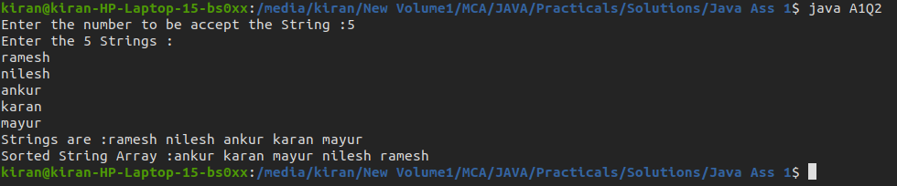

3. Create a Java program to accept two numbers from user, find GCD and LCM of both

the numbers. Use Scanner class to accept two numbers from user.

Solution :

import java.util.\*;

class A1Q3{

public static void main(String args[]){

Scanner sn = new Scanner(System.in);

System.out.print("Enter first Number :");

int x = sn.nextInt();

System.out.print("Enter Second Number :");

int y = sn.nextInt();

int gcd = 1;

for(int i=1;i<=x && i<=y;i++){

if(x%i==0 && y%i==0){

gcd = i;

}

}

System.out.println("GCD of "+x+" & "+y+" is :"+ gcd);

int lcm = (x\*y)/gcd;

System.out.println("LCM of "+x+" & "+y+" is : "+lcm);

}

}

Output :

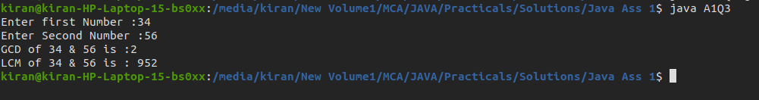

4. Create a Java program to accept a string from user and find the occurrences of

characters in string.

Example:

Input: “beginner”

Output: Occurrence of b is: 1

Occurrence of e is: 2

Occurrence of g is: 1

- - - -

- - - -

Solution :

import java.util.\*;

class A1Q4{

public static void main(String args[]){

Scanner sn = new Scanner(System.in);

System.out.print("Enter the String : ");

String str = sn.nextLine();

int a[] = new int [256];

for(int i=0;i<str.length();i++){

a[str.charAt(i)]++;

}

str = str.replace(" ","");

char ch[] = str.toCharArray();

for(int i=0;i<ch.length;i++){

int cnt = 0;

for(int j=0;j<ch.length;j++){

if(j<i && ch[i]==ch[j])

break;

if(ch[i]==ch[j])

cnt++;

}

if(cnt>0)

System.out.println("Occurance of "+ch[i]+" is "+cnt);

}

}

}

Output :

